31st Annual Conference and Exhibition
Jan. 13-16, 2020
West Palm Beach, FL

This is to certify that

Full Name
attended the STMA 2020 Educational Conference
and is awarded 1.5 CEUs

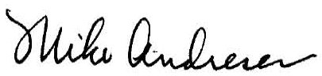
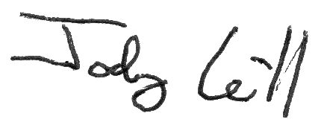
January 17, 2020

