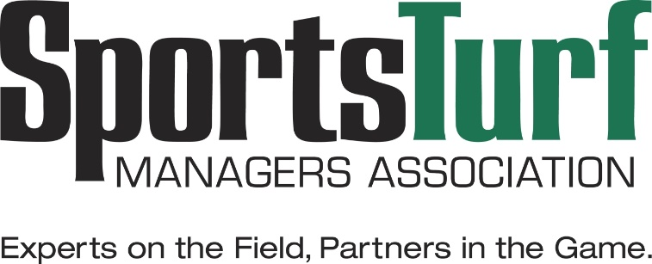

29th Annual Conference and Exhibition
Jan. 16-19, 2018
Fort Worth, TX

This is to certify that

Full Name
attended the STMA 2018 Educational Conference
and is awarded 1.5 CEUs
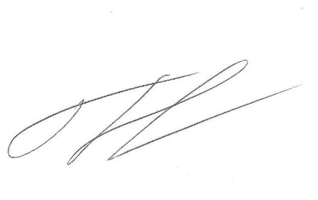

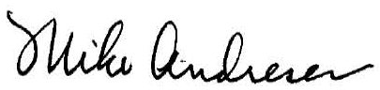
January 29, 2018

